**Common commands**

**ubuntu@ip-172-31-10-134:~$ man cat**

(cat stands for concatenate. To concatenate something is to link or chain parts together. cat streams or prints the output of whatever file you ask for to the Terminal.)

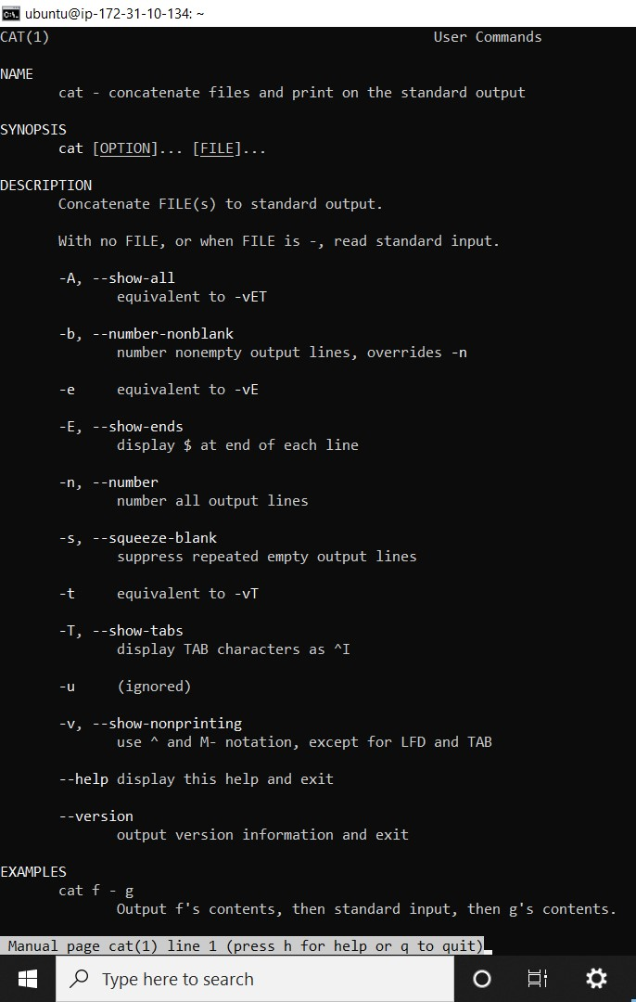

**How to create a file:-**

**touch** -> we use touch command to create a empty file

If we want to create multiple empty file so **touch** command is better.

**touch file1 file2 file3 file4**

**cat ->** we use cat command to fill the data in our file

**cat > file1** (enter)

my name is satyam (enter)

hello boy (enter)

hello giit (ctrl+d)to close the file.

->to view file data we use

**cat file1**

**->if we want to combine 3 file of data in one file**

->cat file1 file2 file3 >file4

->It means all data come in file4

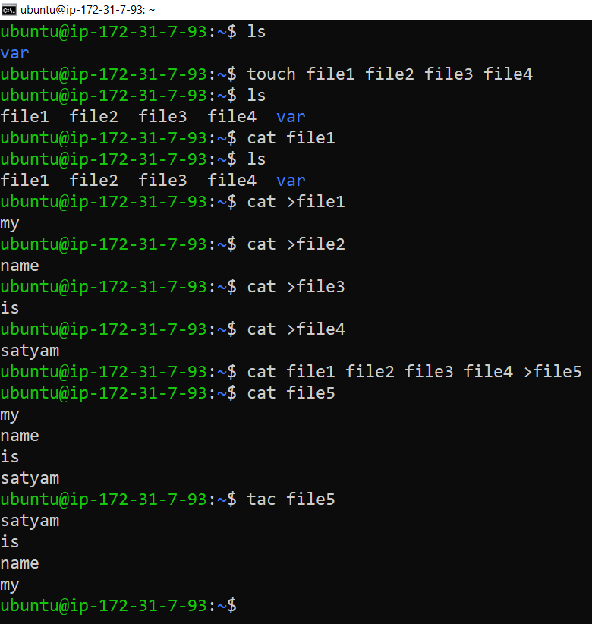

* If we want to change our access time, modify time, change time

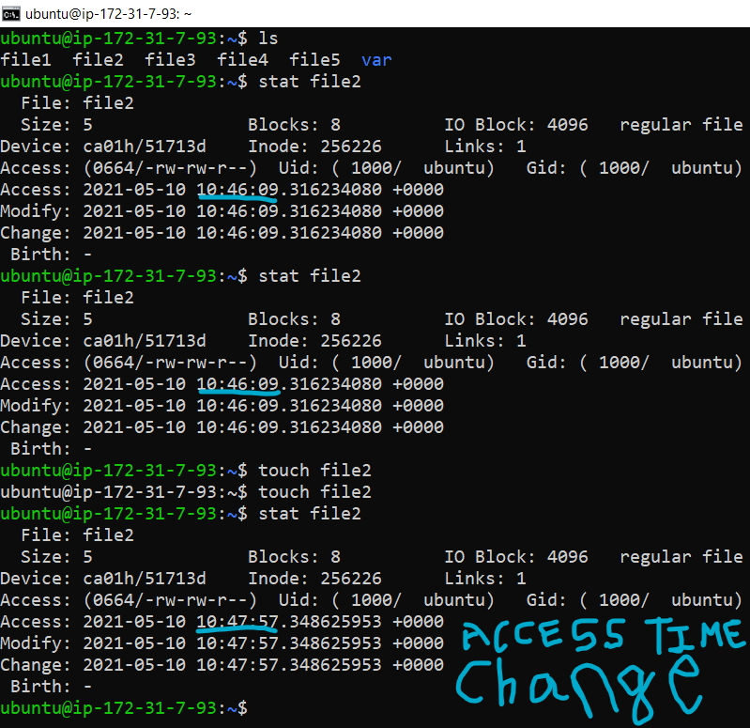

* If we want to change only access time not change modify time so we put this command and one more things when we change our access time our meta date will also update.

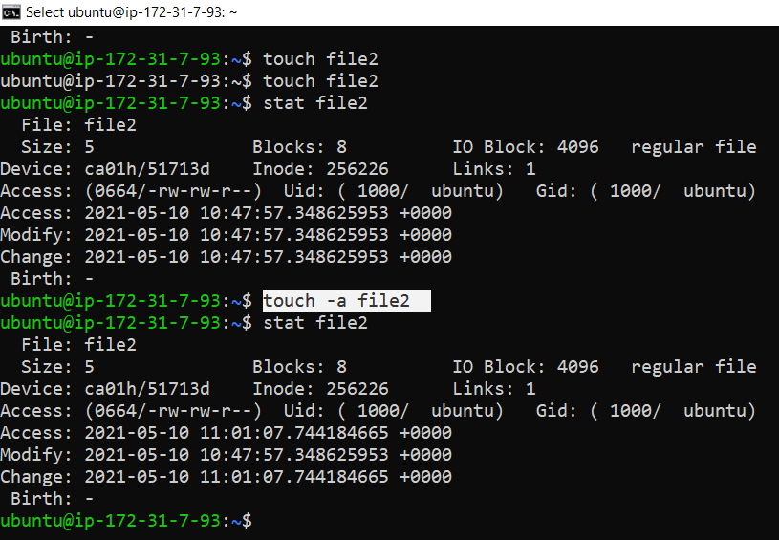

If we want to see our **hidden files** we use ls –a command

**ls -a**

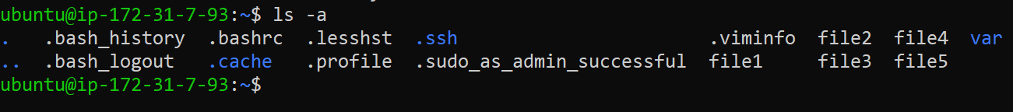

**Sudo su -> we use this command to go to our root user**



**Vi/vim ->** we use this command to create a file or edit a file,

-> firstly we write vi then file name ,**like = vi file5** ,then enter.

->press **i** you see in down insert will come and then you edit your file what you want to edit and then press **esc** and you insert will gone out and again press shift+: you see in down area column**:** will come and press **wq** wq command is save your file and quit it and again when you give command **cat file5** you see your data will be changed.

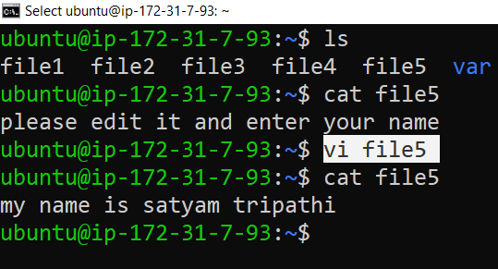

**->**we use **ls –l** command to see our all files detail

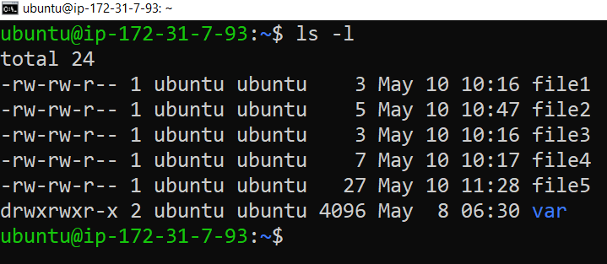

C AT FILE